CIS 554 Homework 2

Homework Objective: Provide students with an opportunity to write a C++ program using basic C++ looping and switch constructs.

Due Date: Refer to Blackboard

Description: A company pays its employees as managers (who receive a fixed weekly salary), hourly workers (who receive a fixed hourly wage for up to the first 40 hours they work and “time and a half”—1.5 times their hourly wage—for overtime hours worked), commission workers (who receive $250 plus 5.7 percent of their gross weekly sales), or pieceworkers (who receive a fixed amount of money per item for each of the items they produce each pieceworker in this company works on only one type of item). Write a class called Worker to compute the weekly pay for each employee. You do not know the number of employees in advance. Each type of employee has its own pay code: Managers have code 1, hourly workers have code 2, commission workers have code 3 and pieceworkers have code 4. Use a switch to compute each employee’s pay according to that employee’s paycode. Within the switch, prompt the user (i.e., the payroll clerk) to enter the type of worker, then call the appropriate Worker method to prompt the user to enter the appropriate information needed to calculate each employee’s pay according to that employee’s paycode. Sample output is provided below. Model your code to produce these results. All work to produce this output must be contained in methods of the Worker class (i.e. not within main).
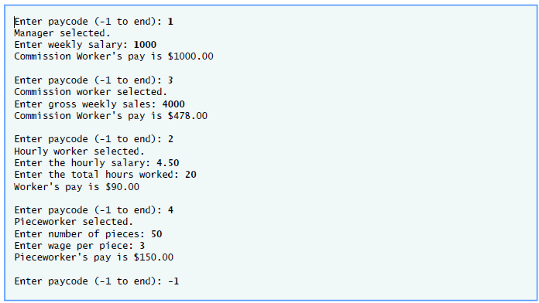
After entering all data for each type of employee, create a bar chart (using a private utility function in the Worker class) that indicates home much money, was earned by each type of employee, rounded to 100’s of dollars. E.g., if $1232 was earned, there would be 12 asterix characters. The bar chart should look something like this:

Managers **********
Hourly *****
Commission ************
Pieceworker *******

Format: Provide the information as follows:

- Zip all the files together. There should be 3 files, Worker.h, Worker.cpp and main.cpp
- Upload the zip file via the web on the Homework page. If you don’t have an ECS account, please get one.
- Please include your full name as part of the header in each source file.
- Please append _HW2 to the .zip file name (e.g. waclawski_HW2.zip).

